МИНИСТЕРСТВО ОБРАЗОВАНИЯ И НАУКИ РОССИЙСКОЙ ФЕДЕРАЦИИ

Фудеральное государственное автономное образовательное учреждение

Высшего образования

**«Национальный исследовательский**

**Нижегородский государственный университет им.Н.И.Лобачевского»**

**(ННГУ)**

**Институт информационных технологий, математики и механики**

**Кафелра математического обеспечения и суперкомпьютерных технологий**

Направление подготовки: «Фундаментальная информатика и

информационные технологии»

Профиль подготовки: «Фундаментальная информатика и информационные

технологии (общий профиль)»

**ОТЧЕТ**

по учебной практике

**Выполнил:** студент группы 381606-2

___________________В.Н. Кутовой

**Проверил:** к.ф.-м.н., доц.

_______________Д.Е. Шапошников

Нижний Новгород

2018

Оглавление

Задача 3

Таблицы 3

Модель базы данных 3

Скрипт создания первоначальной базы данных 4

Database stored procedures 7

Триггер проверки корректности данных 10

Полный дамп базы данных 11

# Задача

## Таблицы

* Преподаватели (Код преподавателя, Фамилия, Имя, Ученая степень, Должность, Стаж).
* Предметы (Код предмета, Название, Тип занятия, Количество часов).
* Нагрузка (Код преподавателя, Код предмета, Номер группы).
* Группы (Код группы, направление)

В результате распределения нагрузки должна получится информация следующего рода: «Такой-то преподаватель проводит занятия по такому-то предмету с такой-то группой».

## Модель базы данных

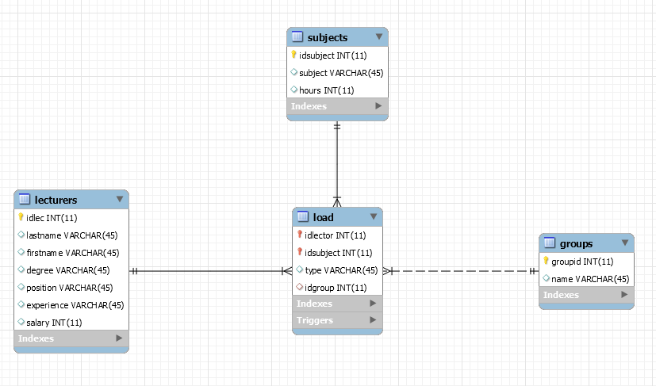

**Lecturers** – таблица преподавателей.

**Subjects** – таблица предметов.

**Group** – таблица учебных групп.

**Load** – таблица распределения учебной нагрузки.

**Таблица Load имеет три Foreign Key:**

1. Idlector – связан с полем idlec таблицы lecturers.
2. Idsubject – связан с полем idsubject таблицы subjects.
3. Idgroup – связан с полем groupid таблицы groups.

**Таблица lecturers:**

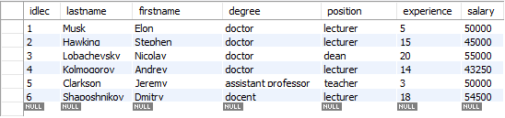

**Таблица subjects:**

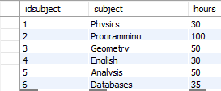

**Таблица groups:**

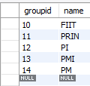

**Таблица load:**

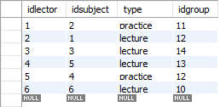

# Скрипт создания первоначальной базы данных

-- MySQL Workbench Forward Engineering

SET @OLD_UNIQUE_CHECKS=@@UNIQUE_CHECKS, UNIQUE_CHECKS=0;

SET @OLD_FOREIGN_KEY_CHECKS=@@FOREIGN_KEY_CHECKS, FOREIGN_KEY_CHECKS=0;

SET @OLD_SQL_MODE=@@SQL_MODE, SQL_MODE='TRADITIONAL,ALLOW_INVALID_DATES';

-- -----------------------------------------------------

-- Schema mydb

-- -----------------------------------------------------

-- -----------------------------------------------------

-- Schema study load

-- -----------------------------------------------------

-- -----------------------------------------------------

-- Schema study load

-- -----------------------------------------------------

CREATE SCHEMA IF NOT EXISTS `study load` DEFAULT CHARACTER SET utf8mb4 ;

USE `study load` ;

-- -----------------------------------------------------

-- Table `study load`.`groups`

-- -----------------------------------------------------

CREATE TABLE IF NOT EXISTS `study load`.`groups` (

`groupid` INT(11) NOT NULL,

`name` VARCHAR(45) NULL DEFAULT NULL,

PRIMARY KEY (`groupid`))

ENGINE = InnoDB;

-- -----------------------------------------------------

-- Table `study load`.`lecturers`

-- -----------------------------------------------------

CREATE TABLE IF NOT EXISTS `study load`.`lecturers` (

`idlec` INT(11) NOT NULL,

`lastname` VARCHAR(45) NULL DEFAULT NULL,

`firstname` VARCHAR(45) NULL DEFAULT NULL,

`degree` VARCHAR(45) NULL DEFAULT NULL,

`position` VARCHAR(45) NULL DEFAULT NULL,

`experience` VARCHAR(45) NULL DEFAULT NULL,

`salary` INT(11) NULL DEFAULT NULL,

PRIMARY KEY (`idlec`))

ENGINE = InnoDB;

-- -----------------------------------------------------

-- Table `study load`.`subjects`

-- -----------------------------------------------------

CREATE TABLE IF NOT EXISTS `study load`.`subjects` (

`idsubject` INT(11) NOT NULL,

`subject` VARCHAR(45) NULL DEFAULT NULL,

`hours` INT(11) NULL DEFAULT NULL,

PRIMARY KEY (`idsubject`))

ENGINE = InnoDB;

-- -----------------------------------------------------

-- Table `study load`.`load`

-- -----------------------------------------------------

CREATE TABLE IF NOT EXISTS `study load`.`load` (

`idlector` INT(11) NOT NULL,

`idsubject` INT(11) NOT NULL,

`type` VARCHAR(45) NULL DEFAULT NULL,

`idgroup` INT(11) NULL DEFAULT NULL,

PRIMARY KEY (`idlector`, `idsubject`),

INDEX `idsubject_idx` (`idsubject` ASC),

INDEX `idgroup_idx` (`idgroup` ASC),

CONSTRAINT `idgroup`

FOREIGN KEY (`idgroup`)

REFERENCES `study load`.`groups` (`groupid`)

ON UPDATE CASCADE,

CONSTRAINT `idlec`

FOREIGN KEY (`idlector`)

REFERENCES `study load`.`lecturers` (`idlec`)

ON UPDATE CASCADE,

CONSTRAINT `idsubject`

FOREIGN KEY (`idsubject`)

REFERENCES `study load`.`subjects` (`idsubject`)

ON UPDATE CASCADE)

ENGINE = InnoDB;

USE `study load` ;

-- -----------------------------------------------------

-- procedure addSubject

-- -----------------------------------------------------

DELIMITER $$

USE `study load`$$

CREATE DEFINER=`root`@`localhost` PROCEDURE `addSubject`(IN idl INT(11), IN ids INT(11), IN tp VARCHAR(45), IN idg INT(11))

BEGIN

INSERT INTO `study load`.load VALUES (idl, ids, tp, idg);

END$$

DELIMITER ;

-- -----------------------------------------------------

-- procedure show

-- -----------------------------------------------------

DELIMITER $$

USE `study load`$$

CREATE DEFINER=`root`@`localhost` PROCEDURE `show`()

BEGIN

SELECT

firstname, lastname, subject, type, name

FROM

`study load`.`load`

JOIN

`study load`.lecturers ON `load`.idlector = `lecturers`.idlec

JOIN

`study load`.subjects ON `load`.idsubject = `subjects`.idsubject

JOIN

`study load`.groups ON `load`.idgroup = `groups`.groupid;

END$$

DELIMITER ;

-- -----------------------------------------------------

-- procedure totalSalary

-- -----------------------------------------------------

DELIMITER $$

USE `study load`$$

CREATE DEFINER=`root`@`localhost` PROCEDURE `totalSalary`()

BEGIN

SELECT SUM(salary) AS `total salary` FROM lecturers;

END$$

DELIMITER ;

USE `study load`;

DELIMITER $$

USE `study load`$$

CREATE

DEFINER=`root`@`localhost`

TRIGGER `study load`.`load_BEFORE_INSERT`

BEFORE INSERT ON `study load`.`load`

FOR EACH ROW

BEGIN

IF(NEW.type != 'lecture' OR NEW.type != 'practice')

THEN

SIGNAL SQLSTATE '02000' SET MESSAGE_TEXT = 'Incorrect type';

END IF;

END$$

DELIMITER ;

SET SQL_MODE=@OLD_SQL_MODE;

SET FOREIGN_KEY_CHECKS=@OLD_FOREIGN_KEY_CHECKS;

SET UNIQUE_CHECKS=@OLD_UNIQUE_CHECKS;

# Database stored procedures

**addSubject**

Процедура позволяет добавить новый предмет и преподавателя в таблицу учебной нагрузки не используя коды преподавателя и предмета, а вводя фамилию преподавателя и название предмета, что облегчает данную задачу в разы. Благодаря связи таблиц с помощью Foreign Key не получится ввести некорректные данные, связанные с idlector, idgroup, idsubject.

Проверка правильности введенного типа занятия (лекция или практика) проходит с помощью триггера (BEFORE INSERT), работа которого будет рассмотрена ниже.

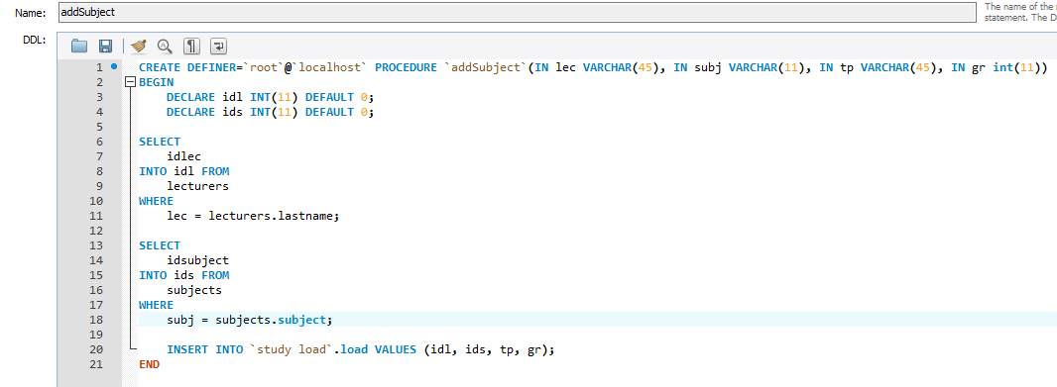

Пример работы процедуры:

1. Введем некорректные данные

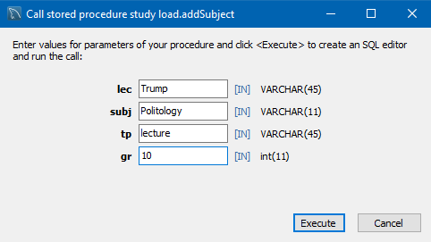

Получим ошибку, процедура не выполнит вставку.

1. Введем корректные данные

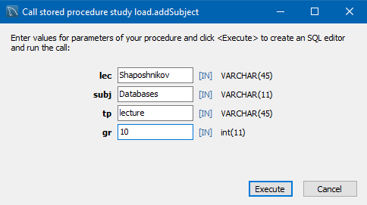



**Show**

Процедура позволяет сформировать удобную для восприятия таблицу учебной нагрузки.

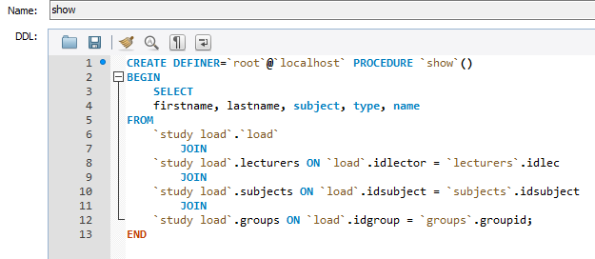

Пример работы процедуры:

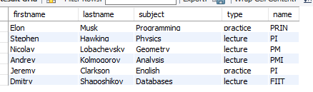

**totalSalary**

Процедура позволяет высчитать общие затраты на зарплаты преподавателей и вывести их как ячейку таблицы.

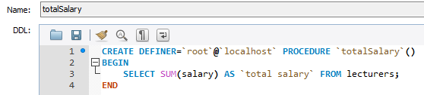

Пример работы процедуры:

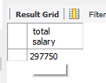

# Триггер проверки корректности данных

Так как проверка всех введенных данных, кроме типа занятия (лекция или практика) осуществляется благодаря Foreign Key, то необходимо использовать простой триггер:

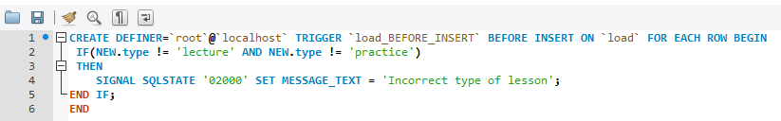

Пример его работы можно было увидеть ранее.

# Полный дамп базы данных

CREATE DATABASE IF NOT EXISTS `study load` /*!40100 DEFAULT CHARACTER SET utf8mb4 COLLATE utf8mb4_0900_ai_ci */;

USE `study load`;

-- MySQL dump 10.13 Distrib 5.7.17, for Win64 (x86_64)

--

-- Host: 127.0.0.1 Database: study load

-- ------------------------------------------------------

-- Server version 8.0.11

/*!40101 SET @OLD_CHARACTER_SET_CLIENT=@@CHARACTER_SET_CLIENT */;

/*!40101 SET @OLD_CHARACTER_SET_RESULTS=@@CHARACTER_SET_RESULTS */;

/*!40101 SET @OLD_COLLATION_CONNECTION=@@COLLATION_CONNECTION */;

/*!40101 SET NAMES utf8 */;

/*!40103 SET @OLD_TIME_ZONE=@@TIME_ZONE */;

/*!40103 SET TIME_ZONE='+00:00' */;

/*!40014 SET @OLD_UNIQUE_CHECKS=@@UNIQUE_CHECKS, UNIQUE_CHECKS=0 */;

/*!40014 SET @OLD_FOREIGN_KEY_CHECKS=@@FOREIGN_KEY_CHECKS, FOREIGN_KEY_CHECKS=0 */;

/*!40101 SET @OLD_SQL_MODE=@@SQL_MODE, SQL_MODE='NO_AUTO_VALUE_ON_ZERO' */;

/*!40111 SET @OLD_SQL_NOTES=@@SQL_NOTES, SQL_NOTES=0 */;

--

-- Table structure for table `groups`

--

DROP TABLE IF EXISTS `groups`;

/*!40101 SET @saved_cs_client = @@character_set_client */;

/*!40101 SET character_set_client = utf8 */;

CREATE TABLE `groups` (

`groupid` int(11) NOT NULL,

`name` varchar(45) DEFAULT NULL,

PRIMARY KEY (`groupid`)

) ENGINE=InnoDB DEFAULT CHARSET=utf8mb4 COLLATE=utf8mb4_0900_ai_ci;

/*!40101 SET character_set_client = @saved_cs_client */;

--

-- Dumping data for table `groups`

--

LOCK TABLES `groups` WRITE;

/*!40000 ALTER TABLE `groups` DISABLE KEYS */;

INSERT INTO `groups` VALUES (10,'FIIT'),(11,'PRIN'),(12,'PI'),(13,'PMI'),(14,'PM');

/*!40000 ALTER TABLE `groups` ENABLE KEYS */;

UNLOCK TABLES;

/*!40103 SET TIME_ZONE=@OLD_TIME_ZONE */;

/*!40101 SET SQL_MODE=@OLD_SQL_MODE */;

/*!40014 SET FOREIGN_KEY_CHECKS=@OLD_FOREIGN_KEY_CHECKS */;

/*!40014 SET UNIQUE_CHECKS=@OLD_UNIQUE_CHECKS */;

/*!40101 SET CHARACTER_SET_CLIENT=@OLD_CHARACTER_SET_CLIENT */;

/*!40101 SET CHARACTER_SET_RESULTS=@OLD_CHARACTER_SET_RESULTS */;

/*!40101 SET COLLATION_CONNECTION=@OLD_COLLATION_CONNECTION */;

/*!40111 SET SQL_NOTES=@OLD_SQL_NOTES */;

CREATE DATABASE IF NOT EXISTS `study load` /*!40100 DEFAULT CHARACTER SET utf8mb4 COLLATE utf8mb4_0900_ai_ci */;

USE `study load`;

-- MySQL dump 10.13 Distrib 5.7.17, for Win64 (x86_64)

--

-- Host: 127.0.0.1 Database: study load

-- ------------------------------------------------------

-- Server version 8.0.11

/*!40101 SET @OLD_CHARACTER_SET_CLIENT=@@CHARACTER_SET_CLIENT */;

/*!40101 SET @OLD_CHARACTER_SET_RESULTS=@@CHARACTER_SET_RESULTS */;

/*!40101 SET @OLD_COLLATION_CONNECTION=@@COLLATION_CONNECTION */;

/*!40101 SET NAMES utf8 */;

/*!40103 SET @OLD_TIME_ZONE=@@TIME_ZONE */;

/*!40103 SET TIME_ZONE='+00:00' */;

/*!40014 SET @OLD_UNIQUE_CHECKS=@@UNIQUE_CHECKS, UNIQUE_CHECKS=0 */;

/*!40014 SET @OLD_FOREIGN_KEY_CHECKS=@@FOREIGN_KEY_CHECKS, FOREIGN_KEY_CHECKS=0 */;

/*!40101 SET @OLD_SQL_MODE=@@SQL_MODE, SQL_MODE='NO_AUTO_VALUE_ON_ZERO' */;

/*!40111 SET @OLD_SQL_NOTES=@@SQL_NOTES, SQL_NOTES=0 */;

--

-- Table structure for table `lecturers`

--

DROP TABLE IF EXISTS `lecturers`;

/*!40101 SET @saved_cs_client = @@character_set_client */;

/*!40101 SET character_set_client = utf8 */;

CREATE TABLE `lecturers` (

`idlec` int(11) NOT NULL,

`lastname` varchar(45) DEFAULT NULL,

`firstname` varchar(45) DEFAULT NULL,

`degree` varchar(45) DEFAULT NULL,

`position` varchar(45) DEFAULT NULL,

`experience` varchar(45) DEFAULT NULL,

`salary` int(11) DEFAULT NULL,

PRIMARY KEY (`idlec`)

) ENGINE=InnoDB DEFAULT CHARSET=utf8mb4 COLLATE=utf8mb4_0900_ai_ci;

/*!40101 SET character_set_client = @saved_cs_client */;

--

-- Dumping data for table `lecturers`

--

LOCK TABLES `lecturers` WRITE;

/*!40000 ALTER TABLE `lecturers` DISABLE KEYS */;

INSERT INTO `lecturers` VALUES (1,'Musk','Elon','doctor','lecturer','5',50000),(2,'Hawking','Stephen','doctor','lecturer','15',45000),(3,'Lobachevsky','Nicolay','doctor','dean','20',55000),(4,'Kolmogorov','Andrey','doctor','lecturer','14',43250),(5,'Clarkson','Jeremy','assistant professor','teacher','3',50000),(6,'Shaposhnikov','Dmitry','docent','lecturer','18',54500);

/*!40000 ALTER TABLE `lecturers` ENABLE KEYS */;

UNLOCK TABLES;

/*!40103 SET TIME_ZONE=@OLD_TIME_ZONE */;

/*!40101 SET SQL_MODE=@OLD_SQL_MODE */;

/*!40014 SET FOREIGN_KEY_CHECKS=@OLD_FOREIGN_KEY_CHECKS */;

/*!40014 SET UNIQUE_CHECKS=@OLD_UNIQUE_CHECKS */;

/*!40101 SET CHARACTER_SET_CLIENT=@OLD_CHARACTER_SET_CLIENT */;

/*!40101 SET CHARACTER_SET_RESULTS=@OLD_CHARACTER_SET_RESULTS */;

/*!40101 SET COLLATION_CONNECTION=@OLD_COLLATION_CONNECTION */;

/*!40111 SET SQL_NOTES=@OLD_SQL_NOTES */;

CREATE DATABASE IF NOT EXISTS `study load` /*!40100 DEFAULT CHARACTER SET utf8mb4 COLLATE utf8mb4_0900_ai_ci */;

USE `study load`;

-- MySQL dump 10.13 Distrib 5.7.17, for Win64 (x86_64)

--

-- Host: 127.0.0.1 Database: study load

-- ------------------------------------------------------

-- Server version 8.0.11

/*!40101 SET @OLD_CHARACTER_SET_CLIENT=@@CHARACTER_SET_CLIENT */;

/*!40101 SET @OLD_CHARACTER_SET_RESULTS=@@CHARACTER_SET_RESULTS */;

/*!40101 SET @OLD_COLLATION_CONNECTION=@@COLLATION_CONNECTION */;

/*!40101 SET NAMES utf8 */;

/*!40103 SET @OLD_TIME_ZONE=@@TIME_ZONE */;

/*!40103 SET TIME_ZONE='+00:00' */;

/*!40014 SET @OLD_UNIQUE_CHECKS=@@UNIQUE_CHECKS, UNIQUE_CHECKS=0 */;

/*!40014 SET @OLD_FOREIGN_KEY_CHECKS=@@FOREIGN_KEY_CHECKS, FOREIGN_KEY_CHECKS=0 */;

/*!40101 SET @OLD_SQL_MODE=@@SQL_MODE, SQL_MODE='NO_AUTO_VALUE_ON_ZERO' */;

/*!40111 SET @OLD_SQL_NOTES=@@SQL_NOTES, SQL_NOTES=0 */;

--

-- Table structure for table `load`

--

DROP TABLE IF EXISTS `load`;

/*!40101 SET @saved_cs_client = @@character_set_client */;

/*!40101 SET character_set_client = utf8 */;

CREATE TABLE `load` (

`idlector` int(11) NOT NULL,

`idsubject` int(11) NOT NULL,

`type` varchar(45) DEFAULT NULL,

`idgroup` int(11) DEFAULT NULL,

PRIMARY KEY (`idlector`,`idsubject`),

KEY `idsubject_idx` (`idsubject`),

KEY `idgroup_idx` (`idgroup`),

CONSTRAINT `idgroup` FOREIGN KEY (`idgroup`) REFERENCES `groups` (`groupid`) ON UPDATE CASCADE,

CONSTRAINT `idlec` FOREIGN KEY (`idlector`) REFERENCES `lecturers` (`idlec`) ON UPDATE CASCADE,

CONSTRAINT `idsubject` FOREIGN KEY (`idsubject`) REFERENCES `subjects` (`idsubject`) ON UPDATE CASCADE

) ENGINE=InnoDB DEFAULT CHARSET=utf8mb4 COLLATE=utf8mb4_0900_ai_ci;

/*!40101 SET character_set_client = @saved_cs_client */;

--

-- Dumping data for table `load`

--

LOCK TABLES `load` WRITE;

/*!40000 ALTER TABLE `load` DISABLE KEYS */;

INSERT INTO `load` VALUES (1,2,'practice',11),(2,1,'lecture',12),(3,3,'lecture',14),(4,5,'lecture',13),(5,4,'practice',12),(6,6,'lecture',10);

/*!40000 ALTER TABLE `load` ENABLE KEYS */;

UNLOCK TABLES;

/*!50003 SET @saved_cs_client = @@character_set_client */ ;

/*!50003 SET @saved_cs_results = @@character_set_results */ ;

/*!50003 SET @saved_col_connection = @@collation_connection */ ;

/*!50003 SET character_set_client = utf8 */ ;

/*!50003 SET character_set_results = utf8 */ ;

/*!50003 SET collation_connection = utf8_general_ci */ ;

/*!50003 SET @saved_sql_mode = @@sql_mode */ ;

/*!50003 SET sql_mode = 'STRICT_TRANS_TABLES,NO_ENGINE_SUBSTITUTION' */ ;

DELIMITER ;;

/*!50003 CREATE*/ /*!50017 DEFINER=`root`@`localhost`*/ /*!50003 TRIGGER `load_BEFORE_INSERT` BEFORE INSERT ON `load` FOR EACH ROW BEGIN

IF(NEW.type != 'lecture' AND NEW.type != 'practice')

THEN

SIGNAL SQLSTATE '02000' SET MESSAGE_TEXT = 'Incorrect type of lesson';

END IF;

END */;;

DELIMITER ;

/*!50003 SET sql_mode = @saved_sql_mode */ ;

/*!50003 SET character_set_client = @saved_cs_client */ ;

/*!50003 SET character_set_results = @saved_cs_results */ ;

/*!50003 SET collation_connection = @saved_col_connection */ ;

/*!40103 SET TIME_ZONE=@OLD_TIME_ZONE */;

/*!40101 SET SQL_MODE=@OLD_SQL_MODE */;

/*!40014 SET FOREIGN_KEY_CHECKS=@OLD_FOREIGN_KEY_CHECKS */;

/*!40014 SET UNIQUE_CHECKS=@OLD_UNIQUE_CHECKS */;

/*!40101 SET CHARACTER_SET_CLIENT=@OLD_CHARACTER_SET_CLIENT */;

/*!40101 SET CHARACTER_SET_RESULTS=@OLD_CHARACTER_SET_RESULTS */;

/*!40101 SET COLLATION_CONNECTION=@OLD_COLLATION_CONNECTION */;

/*!40111 SET SQL_NOTES=@OLD_SQL_NOTES */;

CREATE DATABASE IF NOT EXISTS `study load` /*!40100 DEFAULT CHARACTER SET utf8mb4 COLLATE utf8mb4_0900_ai_ci */;

USE `study load`;

-- MySQL dump 10.13 Distrib 5.7.17, for Win64 (x86_64)

--

-- Host: 127.0.0.1 Database: study load

-- ------------------------------------------------------

-- Server version 8.0.11

/*!40101 SET @OLD_CHARACTER_SET_CLIENT=@@CHARACTER_SET_CLIENT */;

/*!40101 SET @OLD_CHARACTER_SET_RESULTS=@@CHARACTER_SET_RESULTS */;

/*!40101 SET @OLD_COLLATION_CONNECTION=@@COLLATION_CONNECTION */;

/*!40101 SET NAMES utf8 */;

/*!40103 SET @OLD_TIME_ZONE=@@TIME_ZONE */;

/*!40103 SET TIME_ZONE='+00:00' */;

/*!40014 SET @OLD_UNIQUE_CHECKS=@@UNIQUE_CHECKS, UNIQUE_CHECKS=0 */;

/*!40014 SET @OLD_FOREIGN_KEY_CHECKS=@@FOREIGN_KEY_CHECKS, FOREIGN_KEY_CHECKS=0 */;

/*!40101 SET @OLD_SQL_MODE=@@SQL_MODE, SQL_MODE='NO_AUTO_VALUE_ON_ZERO' */;

/*!40111 SET @OLD_SQL_NOTES=@@SQL_NOTES, SQL_NOTES=0 */;

--

-- Dumping events for database 'study load'

--

--

-- Dumping routines for database 'study load'

--

/*!50003 DROP PROCEDURE IF EXISTS `addSubject` */;

/*!50003 SET @saved_cs_client = @@character_set_client */ ;

/*!50003 SET @saved_cs_results = @@character_set_results */ ;

/*!50003 SET @saved_col_connection = @@collation_connection */ ;

/*!50003 SET character_set_client = utf8 */ ;

/*!50003 SET character_set_results = utf8 */ ;

/*!50003 SET collation_connection = utf8_general_ci */ ;

/*!50003 SET @saved_sql_mode = @@sql_mode */ ;

/*!50003 SET sql_mode = 'STRICT_TRANS_TABLES,NO_ENGINE_SUBSTITUTION' */ ;

DELIMITER ;;

CREATE DEFINER=`root`@`localhost` PROCEDURE `addSubject`(IN lec VARCHAR(45), IN subj VARCHAR(11), IN tp VARCHAR(45), IN gr int(11))

BEGIN

DECLARE idl INT(11) DEFAULT 0;

DECLARE ids INT(11) DEFAULT 0;

DECLARE idg INT(11) DEFAULT 0;

SELECT

idlec

INTO idl FROM

lecturers

WHERE

lec = lecturers.lastname;

SELECT

idsubject

INTO ids FROM

subjects

WHERE

subj = subjects.subject;

/*SELECT

groupid

INTO idg FROM

groups

WHERE

gr = groups.name;*/

INSERT INTO `study load`.load VALUES (idl, ids, tp, gr);

END ;;

DELIMITER ;

/*!50003 SET sql_mode = @saved_sql_mode */ ;

/*!50003 SET character_set_client = @saved_cs_client */ ;

/*!50003 SET character_set_results = @saved_cs_results */ ;

/*!50003 SET collation_connection = @saved_col_connection */ ;

/*!50003 DROP PROCEDURE IF EXISTS `show` */;

/*!50003 SET @saved_cs_client = @@character_set_client */ ;

/*!50003 SET @saved_cs_results = @@character_set_results */ ;

/*!50003 SET @saved_col_connection = @@collation_connection */ ;

/*!50003 SET character_set_client = utf8 */ ;

/*!50003 SET character_set_results = utf8 */ ;

/*!50003 SET collation_connection = utf8_general_ci */ ;

/*!50003 SET @saved_sql_mode = @@sql_mode */ ;

/*!50003 SET sql_mode = 'STRICT_TRANS_TABLES,NO_ENGINE_SUBSTITUTION' */ ;

DELIMITER ;;

CREATE DEFINER=`root`@`localhost` PROCEDURE `show`()

BEGIN

SELECT

firstname, lastname, subject, type, name

FROM

`study load`.`load`

JOIN

`study load`.lecturers ON `load`.idlector = `lecturers`.idlec

JOIN

`study load`.subjects ON `load`.idsubject = `subjects`.idsubject

JOIN

`study load`.groups ON `load`.idgroup = `groups`.groupid;

END ;;

DELIMITER ;

/*!50003 SET sql_mode = @saved_sql_mode */ ;

/*!50003 SET character_set_client = @saved_cs_client */ ;

/*!50003 SET character_set_results = @saved_cs_results */ ;

/*!50003 SET collation_connection = @saved_col_connection */ ;

/*!50003 DROP PROCEDURE IF EXISTS `totalSalary` */;

/*!50003 SET @saved_cs_client = @@character_set_client */ ;

/*!50003 SET @saved_cs_results = @@character_set_results */ ;

/*!50003 SET @saved_col_connection = @@collation_connection */ ;

/*!50003 SET character_set_client = utf8 */ ;

/*!50003 SET character_set_results = utf8 */ ;

/*!50003 SET collation_connection = utf8_general_ci */ ;

/*!50003 SET @saved_sql_mode = @@sql_mode */ ;

/*!50003 SET sql_mode = 'STRICT_TRANS_TABLES,NO_ENGINE_SUBSTITUTION' */ ;

DELIMITER ;;

CREATE DEFINER=`root`@`localhost` PROCEDURE `totalSalary`()

BEGIN

SELECT SUM(salary) AS `total salary` FROM lecturers;

END ;;

DELIMITER ;

/*!50003 SET sql_mode = @saved_sql_mode */ ;

/*!50003 SET character_set_client = @saved_cs_client */ ;

/*!50003 SET character_set_results = @saved_cs_results */ ;

/*!50003 SET collation_connection = @saved_col_connection */ ;

/*!40103 SET TIME_ZONE=@OLD_TIME_ZONE */;

/*!40101 SET SQL_MODE=@OLD_SQL_MODE */;

/*!40014 SET FOREIGN_KEY_CHECKS=@OLD_FOREIGN_KEY_CHECKS */;

/*!40014 SET UNIQUE_CHECKS=@OLD_UNIQUE_CHECKS */;

/*!40101 SET CHARACTER_SET_CLIENT=@OLD_CHARACTER_SET_CLIENT */;

/*!40101 SET CHARACTER_SET_RESULTS=@OLD_CHARACTER_SET_RESULTS */;

/*!40101 SET COLLATION_CONNECTION=@OLD_COLLATION_CONNECTION */;

/*!40111 SET SQL_NOTES=@OLD_SQL_NOTES */;

CREATE DATABASE IF NOT EXISTS `study load` /*!40100 DEFAULT CHARACTER SET utf8mb4 COLLATE utf8mb4_0900_ai_ci */;

USE `study load`;

-- MySQL dump 10.13 Distrib 5.7.17, for Win64 (x86_64)

--

-- Host: 127.0.0.1 Database: study load

-- ------------------------------------------------------

-- Server version 8.0.11

/*!40101 SET @OLD_CHARACTER_SET_CLIENT=@@CHARACTER_SET_CLIENT */;

/*!40101 SET @OLD_CHARACTER_SET_RESULTS=@@CHARACTER_SET_RESULTS */;

/*!40101 SET @OLD_COLLATION_CONNECTION=@@COLLATION_CONNECTION */;

/*!40101 SET NAMES utf8 */;

/*!40103 SET @OLD_TIME_ZONE=@@TIME_ZONE */;

/*!40103 SET TIME_ZONE='+00:00' */;

/*!40014 SET @OLD_UNIQUE_CHECKS=@@UNIQUE_CHECKS, UNIQUE_CHECKS=0 */;

/*!40014 SET @OLD_FOREIGN_KEY_CHECKS=@@FOREIGN_KEY_CHECKS, FOREIGN_KEY_CHECKS=0 */;

/*!40101 SET @OLD_SQL_MODE=@@SQL_MODE, SQL_MODE='NO_AUTO_VALUE_ON_ZERO' */;

/*!40111 SET @OLD_SQL_NOTES=@@SQL_NOTES, SQL_NOTES=0 */;

--

-- Table structure for table `subjects`

--

DROP TABLE IF EXISTS `subjects`;

/*!40101 SET @saved_cs_client = @@character_set_client */;

/*!40101 SET character_set_client = utf8 */;

CREATE TABLE `subjects` (

`idsubject` int(11) NOT NULL,

`subject` varchar(45) DEFAULT NULL,

`hours` int(11) DEFAULT NULL,

PRIMARY KEY (`idsubject`)

) ENGINE=InnoDB DEFAULT CHARSET=utf8mb4 COLLATE=utf8mb4_0900_ai_ci;

/*!40101 SET character_set_client = @saved_cs_client */;

--

-- Dumping data for table `subjects`

--

LOCK TABLES `subjects` WRITE;

/*!40000 ALTER TABLE `subjects` DISABLE KEYS */;

INSERT INTO `subjects` VALUES (1,'Physics',30),(2,'Programming',100),(3,'Geometry',50),(4,'English',30),(5,'Analysis',50),(6,'Databases',35);

/*!40000 ALTER TABLE `subjects` ENABLE KEYS */;

UNLOCK TABLES;

/*!40103 SET TIME_ZONE=@OLD_TIME_ZONE */;

/*!40101 SET SQL_MODE=@OLD_SQL_MODE */;

/*!40014 SET FOREIGN_KEY_CHECKS=@OLD_FOREIGN_KEY_CHECKS */;

/*!40014 SET UNIQUE_CHECKS=@OLD_UNIQUE_CHECKS */;

/*!40101 SET CHARACTER_SET_CLIENT=@OLD_CHARACTER_SET_CLIENT */;

/*!40101 SET CHARACTER_SET_RESULTS=@OLD_CHARACTER_SET_RESULTS */;

/*!40101 SET COLLATION_CONNECTION=@OLD_COLLATION_CONNECTION */;

/*!40111 SET SQL_NOTES=@OLD_SQL_NOTES */;

-- Dump completed on 2018-05-31 22:31:00